Post - http://localhost:3003/auth/register

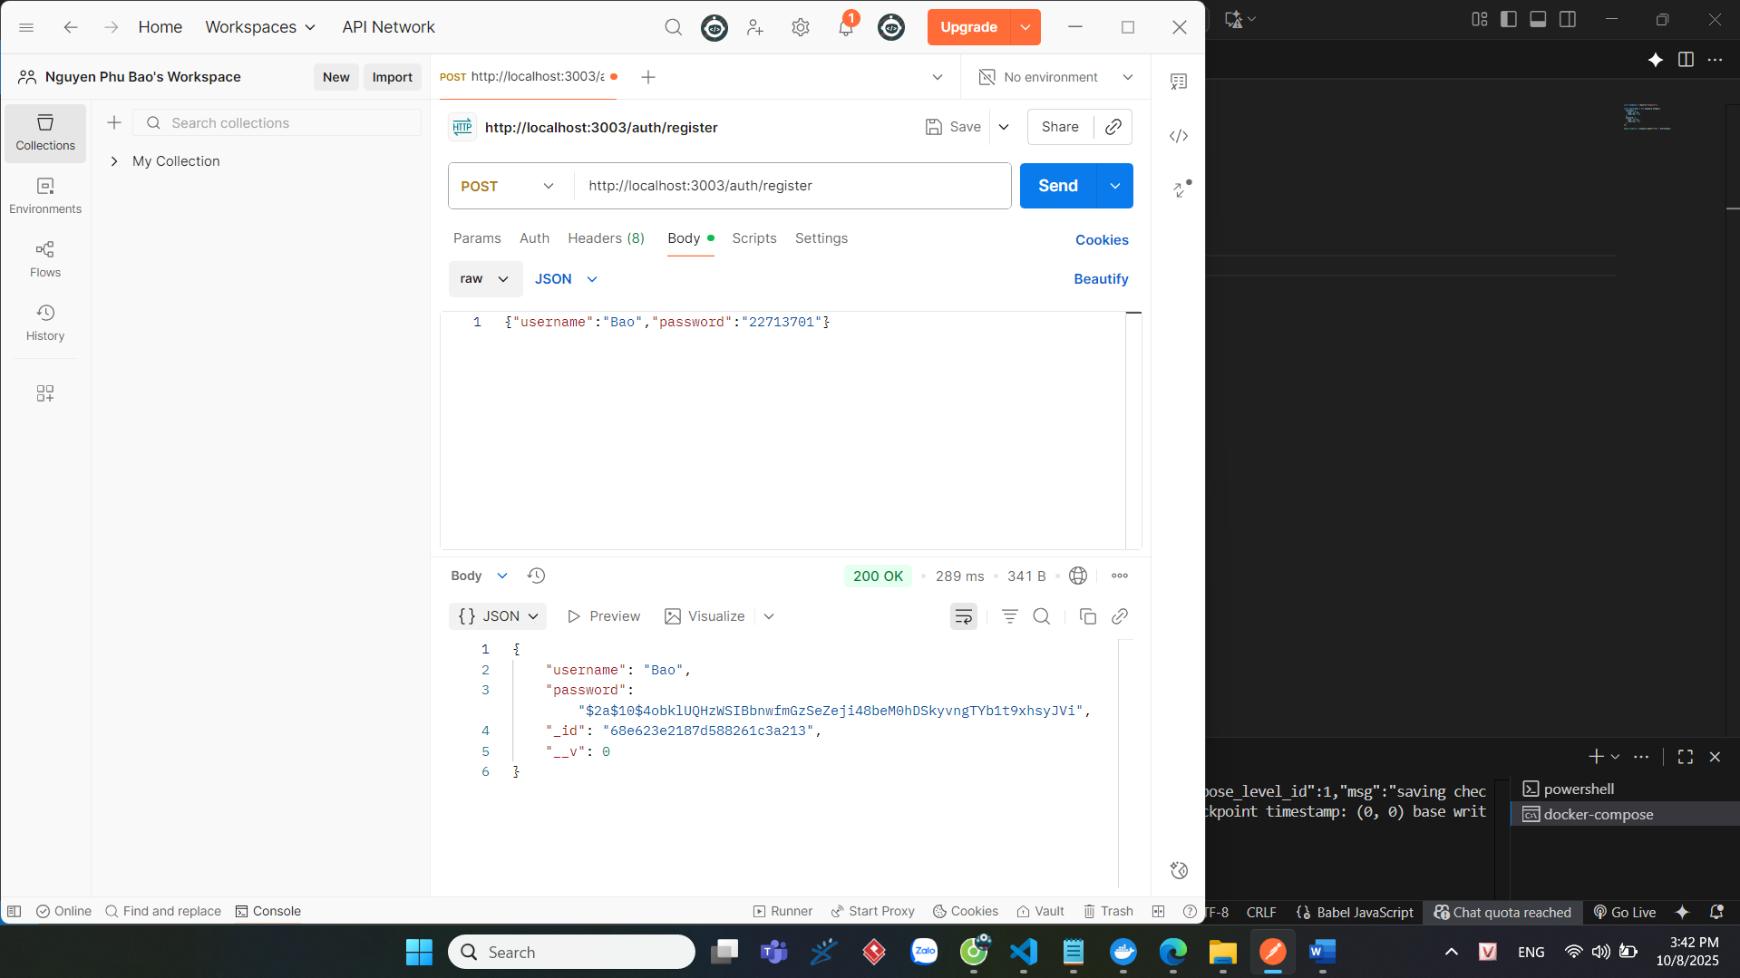

Post-http://localhost:3003/auth/login

Get-http://localhost:3003/auth/dashboard

Post-http://localhost:3003/products/api/products/

Get-http://localhost:3003/products/api/products/

Post-http://localhost:3003/products/api/products/buy

